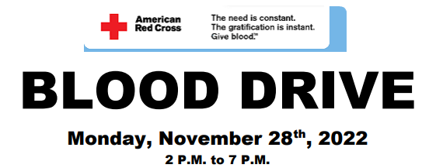

Hosted by our very own Madelyn Oswald
When; Monday, November 28th, 2022 2 P.M. to 7 P.M at the Gospel of Grace Christian School
Where; 315 Central Avenue, Cheltenham, PA 19012
Contact information - len.jjr@cheltenhamfirecompany.org
To schedule; http://www.redcrossblood.org - Sponsor code = Gospel of Grace Church

ABOUT OUR HOST
At just 12 years old, Madelyn Oswald was acutely aware of the need for blood donation. Earlier this spring, Madelyn went from being a perfectly well active child, to the septic shell of herself. She wasn't even stable enough to undergo the lifesaving surgery she desperately needed, all within just 12 short hours.
Without any of the usual warning signs, Madelyn's appendix suddenly ruptured. At Children's Hospital of Philadelphia, the medical staff struggled to gain control of Madelyn's erratic condition. After exhausting all other available options, it became clear to her team, that Madelyn needed a unit of plasma. This last resort would have been considered much sooner, if not for the shortage in supply.
Upon learning of the Doctor's orders, and without realizing the danger she was in, Madelyn urgently requested that the blood be used to "help someone who needs it more" then she did. Madelyn pleaded then and there, with EVERY nurse, aide, doctor, and parent she encountered during her 16 day recovery in the hospital to donate blood and share her message with every eligible person they knew, to do their part, to end this crisis.
Please share Madelyn's message, and encourage those you know, to make this selfless choice, to donate blood. Use the App and see when and where you blood is used after donation.

